# Introduction

The logistics industry, pivotal to the global economy, is witnessing transformative shifts driven by digitalization, consumer expectations, and sustainability imperatives. The emergence of advanced technologies such as indoor mobile robots, automated inventory management systems, and the expansion of logistics services to include end-to-end solutions are reshaping the landscape. These innovations offer the potential to significantly reduce operational costs, enhance efficiency, and meet the evolving demands of consumers and businesses alike.

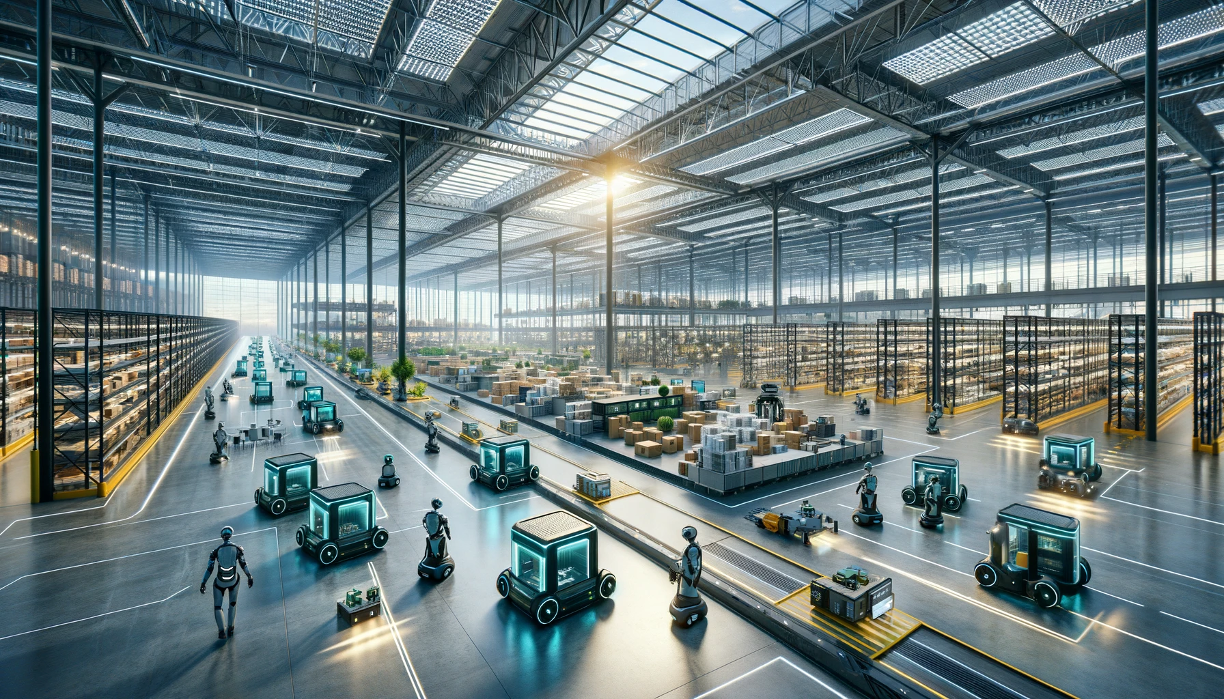

In the dynamic and complex world of global logistics, DHL is a key force driving the industry forward. Our team’s journey into the world of logistics and delivery services begins not only from an academic or professional perspective, but also from personal experiences that highlight the challenges within the industry. Logistics has been subtle into everyone's life, we are more or less will be online shopping or receive the family or friends of the items sent; or have had to sell items, or will be sent to the heart and feelings of the important people who are not close to the experience, which are dependent on the logistics of this very important industry! This industry underpins the fabric of our modern interconnected world, facilitating not just the movement of goods but also the exchange of emotions and intentions across vast distances. Coming from diverse backgrounds in Asia and Europe, we each bring our own unique perspective and are united by our common interest in DHL. Our initial contact with the company, whether through direct interaction or through the lens of news and discussions, revealed a series of operational challenges that fueled our curiosity and concern.



Upon arrival in the Netherlands, our personal experience with receiving goods exposed the flaws of the “last mile” delivery process. Problems with couriers leaving packages unattended at apartment doorsteps without any communication, collection points having inconvenient opening hours that overlap with normal business hours, and packages being damaged or lost paint a picture of an inefficient system. These first-hand experiences, coupled with widespread reports of similar issues, prompted us to dig deeper into the underlying issues.

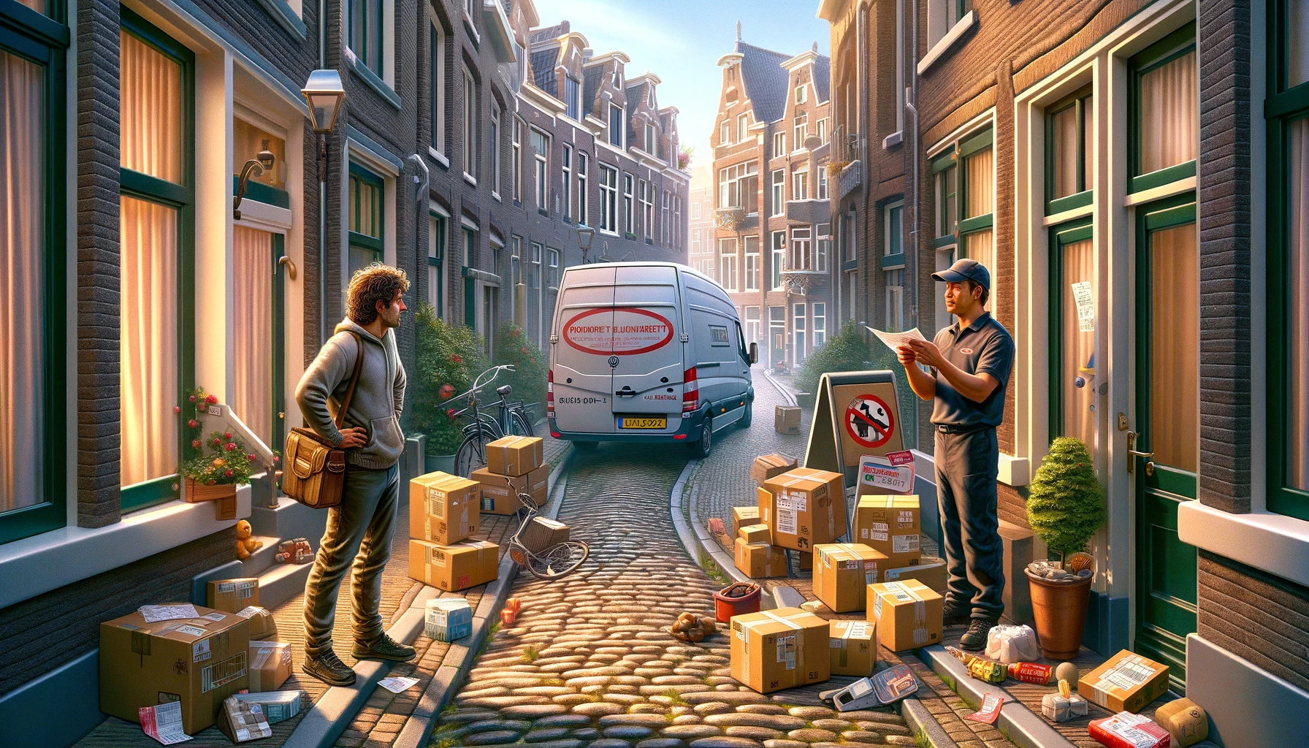

Driven by these direct experiences and the desire to uncover the root causes of these logistics challenges, we decided to focus our analysis on the “last mile” delivery area. Our goal is to explore beyond the superficial issues encountered by individuals to identify and resolve systemic procedural issues within DHL operations, hoping to contribute to meaningful improvements in the logistics industry.

# Background

The genesis of DHL dates back to 1969, marking the inception of a global powerhouse in logistics and express delivery. What began as a disruptive idea to expedite cargo documentation delivery has transformed into a global network spanning over 220 countries and territories. DHL's journey from its humble beginnings to becoming a subsidiary of the world's leading postal and logistics company, Deutsche Post DHL Group, is a testament to its pioneering spirit and commitment to excellence.

Over the decades, DHL has not only expanded its service portfolio but also embraced technological advancements and sustainability initiatives. In response to the escalating demands of e-commerce and the imperative for green logistics, DHL has set ambitious goals. These include achieving zero emissions by 2050, a commitment that reflects the company's dedication to environmental stewardship and its proactive approach to addressing the challenges of modern logistics.

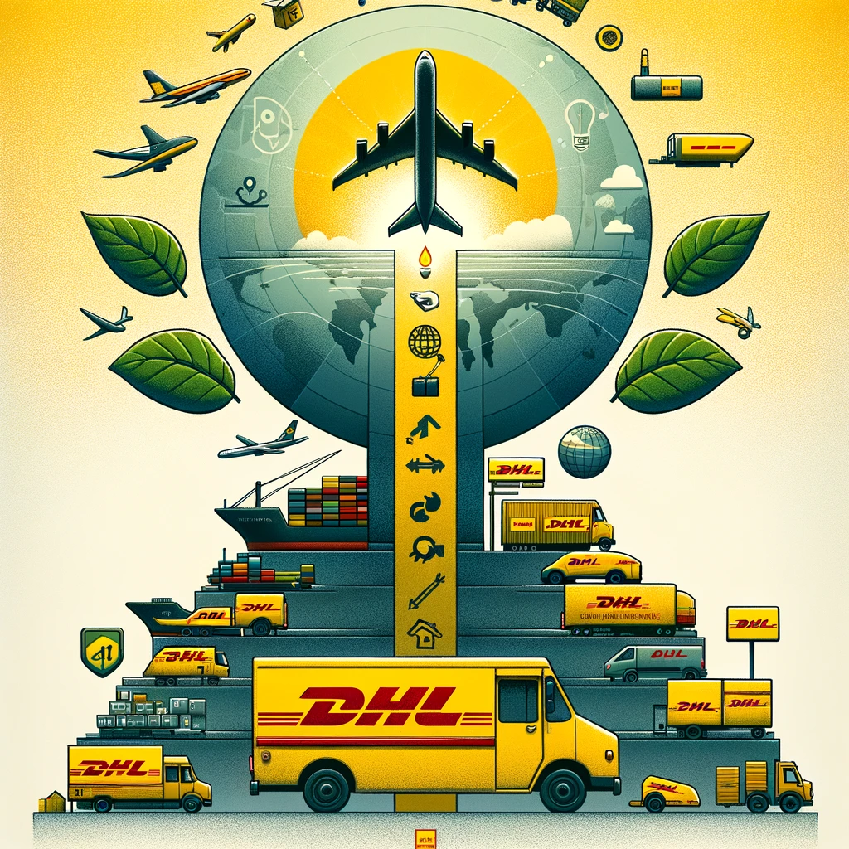

DHL's operational model, characterized by its extensive network of sorting centers, delivery vans, service points, and innovative solutions like locker walls, is designed to cater to the dynamic needs of global commerce. Through strategic investments in digitalization and sustainable practices, DHL aspires to redefine the standards of delivery services, ensuring reliability, efficiency, and minimal environmental impact.

# Reference

* DHL. (2023). Logistics Trends 2023. [DHL Logistics Trends](https://www.dhl.com/)
* KPMG. (2023). The supply chain trends shaking up 2023. KPMG Global Supply Chain Trends
* TAWI. (2023). Logistics Trends for 2023: The top 5 trends in logistics. [TAWI Logistics Trends](https://www.tawi.com/)
* DHL Freight. (2023/2024). Logistics Trends 2023/2024: Which Direction for AI? [DHL Freight AI in Logistics](https://dhl-freight-connections.com/)

GPT’s simple version:

**Introduction**

The logistics sector, essential to the global economy, is undergoing major transformations due to digitalization, evolving customer expectations, and the push for sustainability. Innovations like autonomous indoor robots, smart inventory management, and comprehensive logistics solutions are streamlining operations, cutting costs, and enhancing efficiency to meet modern demands. Within this evolving landscape, DHL plays a crucial role, propelled by both professional insights and personal encounters that reveal significant industry challenges.

Logistics touches every aspect of our lives, from online shopping to sending gifts to those far away, underscoring its importance in our daily interactions and emotional exchanges. Our diverse team, with roots in Asia and Europe, shares a unified focus on DHL, sparked by firsthand experiences and external discussions that have exposed operational inefficiencies, especially in last-mile delivery. Issues such as unattended packages, inconvenient collection point hours, and lost or damaged goods have driven us to explore systemic flaws deeper.

Fueled by these experiences, we aim to dissect and address the underlying issues in DHL's last-mile delivery process, striving for improvements that could revolutionize logistics services.

**Background**

DHL's foundation in 1969 was the start of a journey to become a leading force in logistics and express delivery, now operating in over 220 countries and territories. From its early disruptive strategies to its current status under Deutsche Post DHL Group, DHL exemplifies innovation and excellence.

The company has expanded its offerings and embraced new technologies and sustainability, aiming for zero emissions by 2050. Its operational model, featuring a vast network of facilities and digital solutions, seeks to meet the demands of global commerce with efficiency and minimal environmental impact.